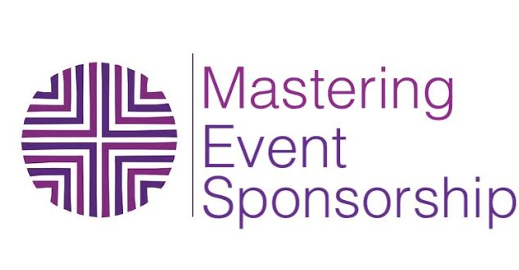

SPONSOR ATTRACTIVE SALES SCRIPT

Ideally you want to make this call about 20 minutes long. Following the sequence below should support you to streamline this process.

CONNECT- 2 MIN

Create connection with your prospective sponsor.

Hi ------, I’m so happy to have been connected to you (include a personal anecdote about them or the type of the work they do)

I’d love to share with you about my event and then of course hear about the work and who you work with and see if it makes sense for us to work together- sound ok?

GIVE INFO- 5 MIN

Give a brief but detailed description of your event

The event happens x times a year and is x hours long. Next one is on (date)
The way it is set up is so attendees arrive at 6pm and are free to walk around and experience x (modify to be a description of what will happen at your event) There is a 30 minute break at 8pm so that x happens. Attendees are working professionals (include a phrase to describe who your attendees are) between the ages of x and x and are coming because they are (include some information based on your research)

Insert the reason why people would sponsor in the description. Here is what I say:
I feature 8 experts, who sit down 1 on 1 with attendees in a mini consult, they are able to connect with you as an expert and the idea is that before they leave your table they have signed up for a future consult. This is a way for you to get in front of x amount of prospects in one place.

BE AVAILABLE

Your prospect may ask questions, about how participating works and what it costs.

If they don’t – mention that you will share how to participate and all that is involved but first you would love to know a little about them.

INQUIRE- 5 MIN

Be authentically interested in your prospective sponsor. You want to ask questions to make sure that they are a good fit for your event.

Tell me more about your work.

Who is your ideal client?
Find out most of the info you have outlined for yourself in the attendee profile.

How do you normally find your clients?

Include these GEM statements:

- I want to make sure your clients are a match to the attendees that will be at the event, I don’t want this to be a waste of your time, energy and money
- I want to have an idea of your services and pricing so that you are placed at the correct level of sponsorship and can make a return on your investment sooner than later.

Do you work with your clients long term? Or session by session?

If your sponsor is a product vendor then ask:

What’s the price range of what you’re offering?
* This is important so you know what level to place your sponsor in

BE CONFIDENT- 3 MIN

After listening to your sponsor share about who they are and what they have to offer transition into sharing the investment for sponsorship. This is when you get to make a bold and assured statement that this is a paid sponsorship:

Participating at the event is through a paid sponsorship. For someone like you who works one on one with clients over time (or who has products in this price range) you would be coming on board as a GOLD sponsor (x sponsor- whatever name you give your levels)

Before you give the price recap the benefits they receive and then tag on the price:

So as a GOLD sponsor you receive the 1 on1 consultation station, an opportunity to include something in the goodie bag as well as promotions that happen before and after the event, the 5 social media promotions, editor access to the Face Book community group where you share about your business at any time. All of this is included for $500.

CLARIFY- 3-5 MIN

Ask if anything needs to be clarified and be available once again to answer questions.

Common questions prospective sponsors ask:

How many people attend?
How do you market and promote the event?
Can you guarantee the amount of people who come?
Is there a cost to the attendees? How much are tickets?

How long have you been doing this?
How did you get into this?

Be prepared to answer these questions and DON’T worry if this is your first event. Remember to back up your experience with all the years you have invested in learning the information that is part of the reason you are crafting your event.

CLOSE 2 MIN

If they are a YES!!:
Say great! So what will happen next is that I will send you an agreement and process your payment. How do you want to take care of that?

For any sponsors that are not a YES on the spot. Tell them that you have all this information in a document that you can send it to them for them to review.

GEM statement:

Take your time to read it through and really feel if this is a good match for you at this time.

Let’s schedule a time to reconnect * pick a date that is NOT more than 5 days to a week max away!.

Do not get off the phone without scheduling a specific date for your second call.

Then email them the sponsorship info when you get off the phone.

